 TROVARA CREDITS
CUSTOMER ACCOUNT INVITATION
Subject: Trovara Farm account invitation
Preheader: An invitation to create your Trovara Farm account.
Hi {{first_name}},
Because you completed our survey and asked Trovara Farm to stay in touch, you're eligible for Trovara Credits.
Claim your Trovara Farm account to receive 2,000 Trovara Credits and unlock your personal referral link.
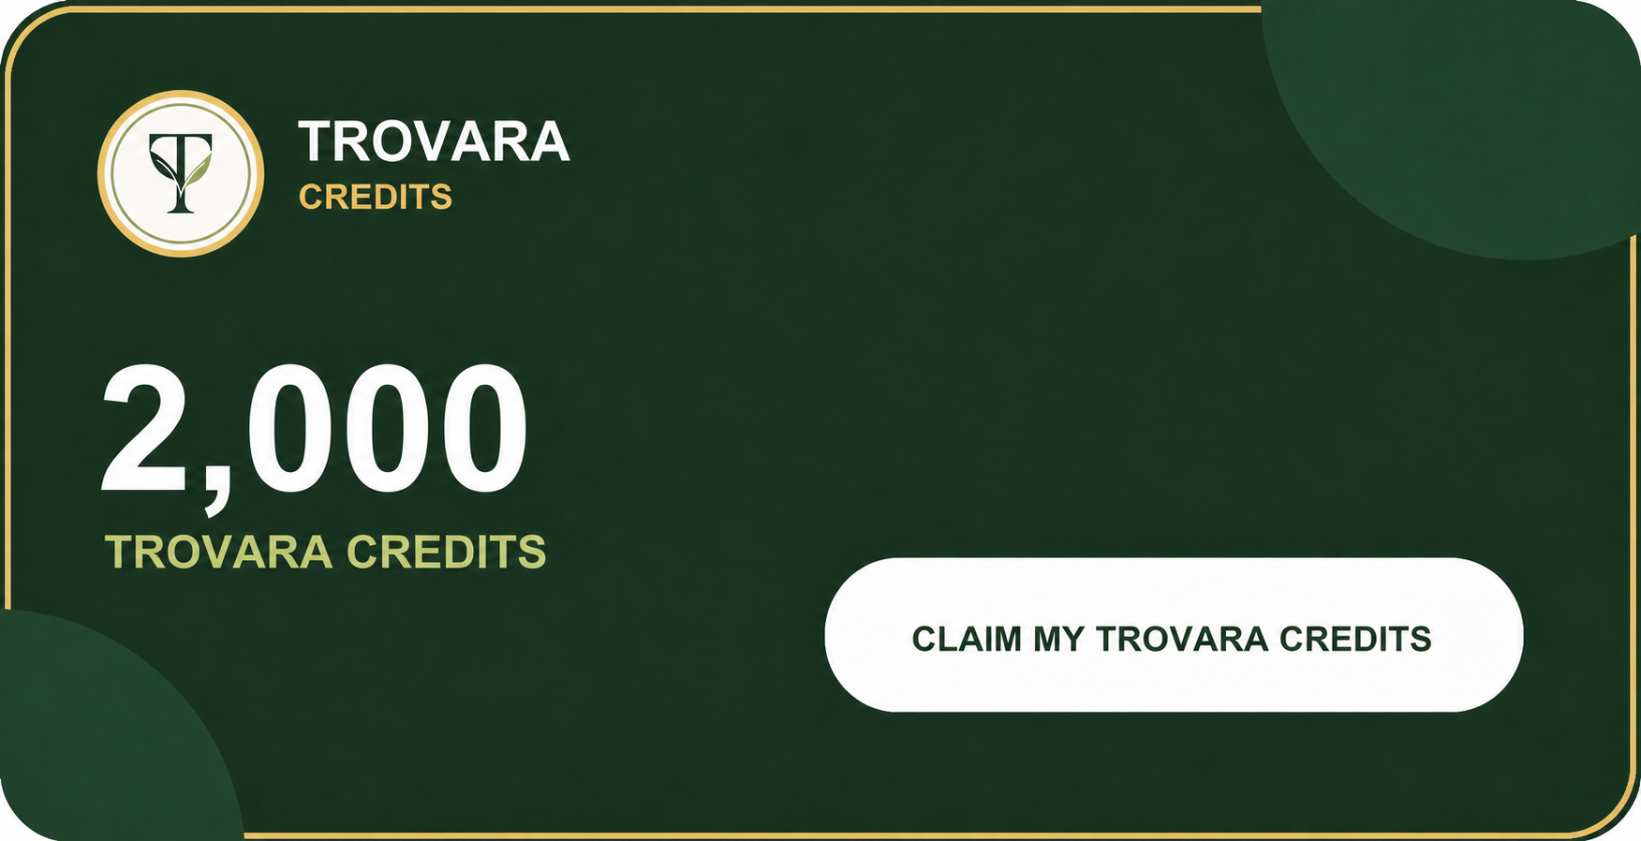
{{activation_url}}
SHARE THE GOOD FOOD
Once activated, share your referral link so friends who complete the survey can unlock their own 2,000 Trovara Credits.
Full referral details and programme terms will be shown during account activation.
P.S. Get 1,000 more Trovara Credits when your referral completes their first eligible Trovara Farm purchase. The credits become available after the purchase passes its refund period without a refund.
P.P.S. Trovara Credits can only be used to buy eligible products sold by Trovara Farm. They are promotional credits, not cash.
Instagram · TikTok · Facebook · LinkedIn
From all of us at Trovara Farm
Food you can trust, from a farm built for tomorrow.
You are receiving this because you asked Trovara Farm to contact you after completing our survey. Privacy · Unsubscribe

